[CREATE TABLE Payroll(empid int PRIMARY KEY, basicpay int, conveyance int,tax int);](javascript:sc_postHistory('46068405635765705835','IN_A791_PLSQL_S36');)

DECLARE

CURSOR

s1 IS SELECT \* FROM Payroll1;

BEGIN

FOR c1 in s1

LOOP

IF c1.basicpay<20000 THEN

UPDATE Payroll1

SET TAX=0.1\*c1.basicpay

WHERE empid=C1.empid;

ELSE IF c1.basicpay>=20000 AND c1.basicpay<30000 THEN

UPDATE Payroll1

SET TAX=0.2\*c1.basicpay

WHERE empid=C1.empid;

ELSE

UPDATE Payroll1

SET TAX=0.3\*c1.basicpay

WHERE empid=C1.empid;

END IF;

END IF;

END LOOP;

END;

/

SELECT \*FROM Payroll1;

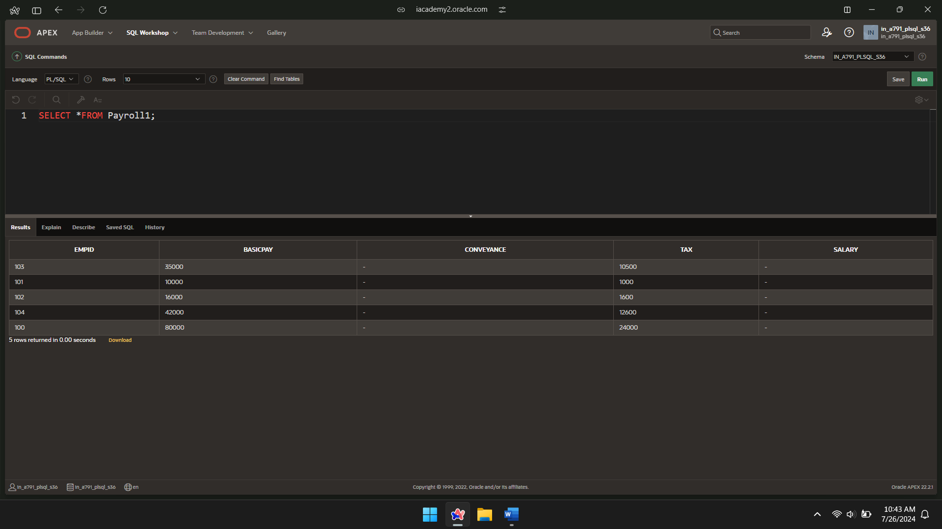

DECLARE

CURSOR

s1 IS SELECT \* FROM Payroll1;

BEGIN

FOR c1 in s1

LOOP

IF c1.basicpay<20000 THEN

UPDATE Payroll1

SET Conveyance=0.3\*c1.basicpay

WHERE empid=C1.empid;

ELSE IF c1.basicpay>=20000 AND c1.basicpay<30000 THEN

UPDATE Payroll1

SET Conveyance=0.2\*c1.basicpay

WHERE empid=C1.empid;

ELSE

UPDATE Payroll1

SET Conveyance=0.1\*c1.basicpay

WHERE empid=C1.empid;

END IF;

END IF;

END LOOP;

END;

/

SELECT \*FROM Payroll1;

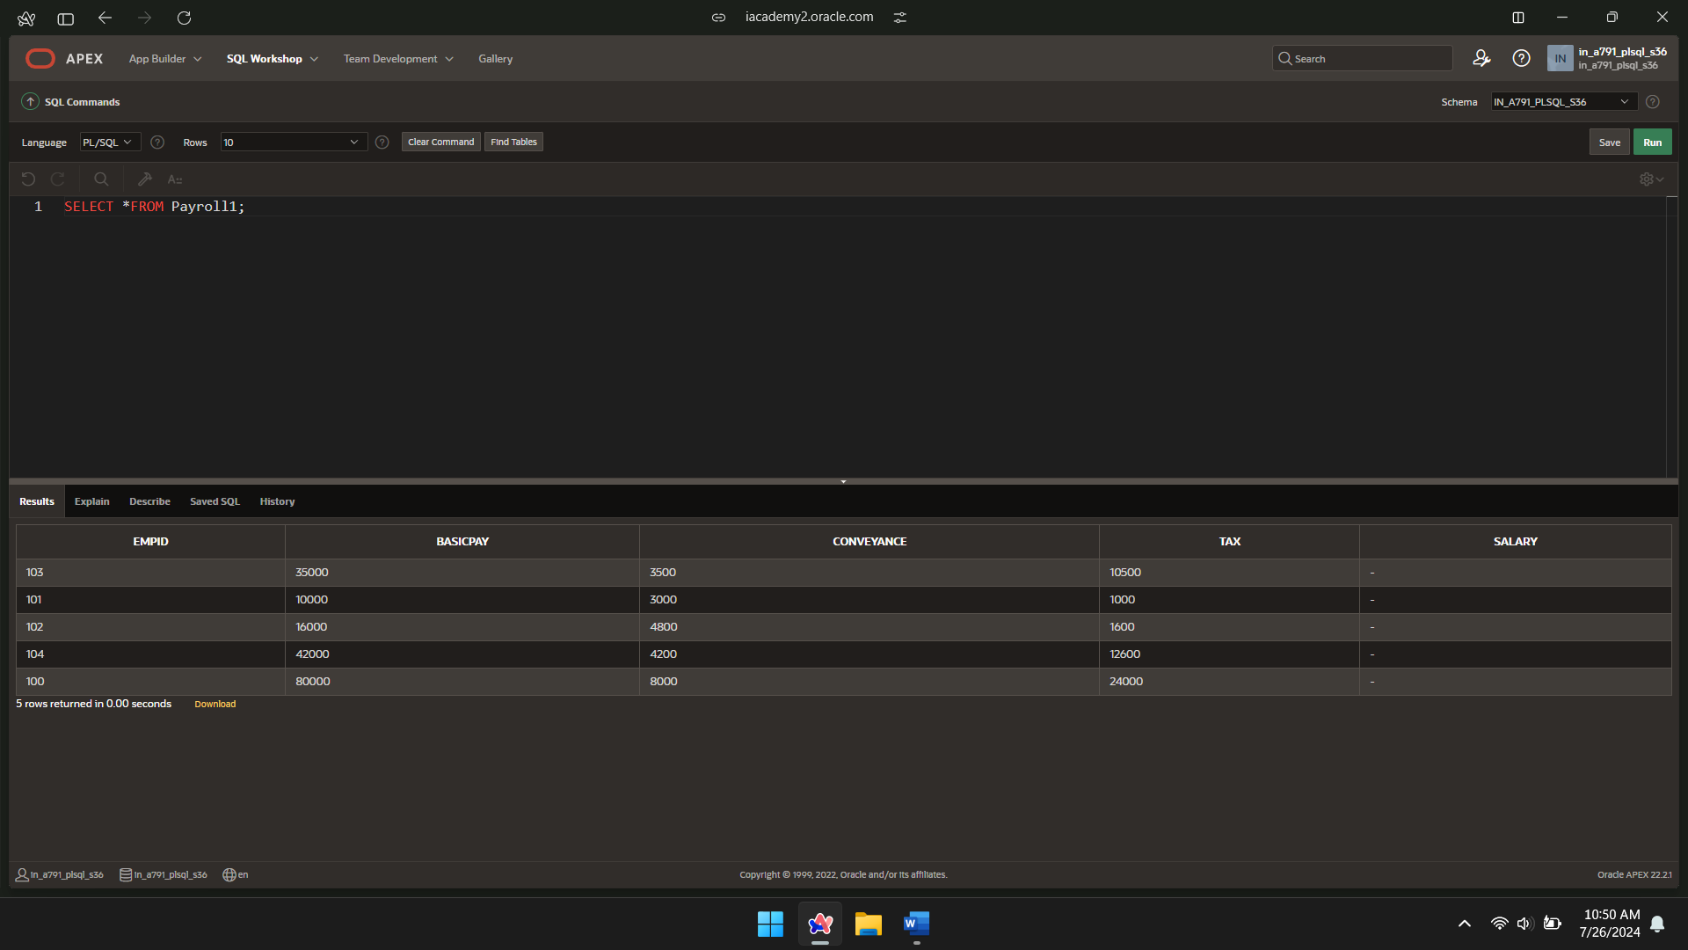

DECLARE

CURSOR

s1 IS SELECT \* FROM Payroll1;

BEGIN

FOR c1 in s1

LOOP

IF c1.basicpay<20000 THEN

UPDATE Payroll1

SET SALARY=basicpay+conveyance-tax

WHERE empid=C1.empid;

ELSE IF c1.basicpay>=20000 AND c1.basicpay<30000 THEN

UPDATE Payroll1

SET SALARY=basicpay+conveyance-tax

WHERE empid=C1.empid;

ELSE

UPDATE Payroll1

SET SALARY=basicpay+conveyance-tax

WHERE empid=C1.empid;

END IF;

END IF;

END LOOP;

END;

/

SELECT\*FROM Payroll1;

